**Rapunzel assignment:**

Tech Stack used in this assignment: Asp.net core API, React, Ajax, JavaScript ,jQuery ,GitHub.

Testing : Test it on server for eg : <https://localhost:44323/api/Datasearch> , <https://localhost:44323/SearchValue.html>

**Goal:**

* Make this data searchable using modern AJAX web technology
  + Implemented searchable data logic in SearchValue.html, SearchFunctionality.js , controller: DataSearch.cs file and searched data from rapunzelproducts.json file.
  + Added these file in asp.net core API application and updated the code to accommodate our logic .

**Requirements:**

* Implementation must use JavaScript and HTML5 atleast, frontend should preferable be using React

Used Javascript, html5,ajax, jquery . As mentioned earlier, have not worked with React before but I tried to work on a react solution to implement the same logic over there.

Please check index.js and SearchDatacontroller.cs file in ReactJson solution

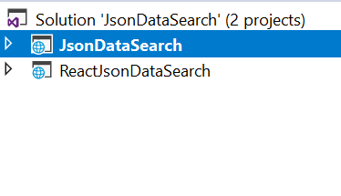

* Search logic should be implemented in suitable backend : .net core api logic is used for this .
* A search for tape sleek should match a product named "Sleek Tape Extension M7.1/10.8 Natural Ash Blonde Mix 25 cm " :

Following logic is used for the same.

$.getJSON('rapunzelproducts.json', function (data) {

$.each(data, function (key, value)

**Meriting:**

* Writing code with reusability in mind : Basic project is created keeping this in mind
* Search match precision : Implemented
* Search results ordered by relevance
* Solution elegance: Implemented
* Visual design: Implemented
* Security awareness : I am aware of this logic ,however didn’t get time to fix it correctly.
* Error handling

**Keep in mind:**

* Frameworks are allowed, but not required.
* Comments are useful, they help us understand your thought process
* This exercise is **not** meant to take more than a **few hours**